DCC-GARCH correlation: NZDUSD and USDJPY
Method 09 / GARCH(1,1) + Engle DCC / Alpari D1 full available history

Study setup
Logical pair: NZDUSD , USDJPY
Broker symbols: NZDUSD_i , USDJPY_i
Snapshot: 2026-11-03_majors_alpari_D1
Timeframe: D1
Matched return window: 1999-01-05 to 2026-11-02 (UTC bar dates)
Matched return count n: 7185
Dropped unfinished last bar dated 2026-11-03 UTC after a tick-volume check against the prior complete day.
NZDUSD GARCH(1,1): mu=0.000006, omega=0.004848, alpha=0.040259, beta=0.950893
USDJPY GARCH(1,1): mu=0.000111, omega=0.005037, alpha=0.052325, beta=0.934935
DCC: a=0.041274, b=0.941046, a+b=0.982320
Burn-in ignored in path summaries and chart: first 60 updates
Complete matched rows (Excel): NZDUSD-USDJPY_DCC_D1.xlsx
Complete matched rows (HTML table): NZDUSD-USDJPY_DCC_D1_data.html

Method carried forward
DCC-GARCH first fits a constant-mean GARCH(1,1) on each matched daily log return of close, ln(close_t / close_t-1), then updates Engle (2002) dynamic conditional correlation on the standardised shocks z = residual / conditional sigma. Quotes are not inverted. Correlation targeting sets Q_bar to the sample correlation of z; a and b are estimated by maximising the bivariate Gaussian DCC likelihood with a >= 0, b >= 0, and a + b < 1. Path summaries ignore the first 60 updates. The headline is rho on the last day. Same-sample Pearson r on log returns is a side check only. A high |rho| does not prove cause, lead-lag, or a trading signal.

Results
Latest DCC rho: -0.194392
Post-burn-in path (n=7125): mean=-0.239282, median=-0.273248, min=-0.675299, max=0.678229, std=0.225947
Share of post-burn-in days with |rho| >= 0.4: 27.82%; |rho| >= 0.7: 0.00%
Same-sample Pearson r: -0.133568
Latest rho minus r: -0.060824

Conclusion
Over 7185 matched daily log-return rows for NZDUSD and USDJPY (broker quote directions unchanged), latest DCC rho is -0.1944 (negative, weak conditional linear link in this sample) with fitted a=0.0413, b=0.9410 (a+b=0.9823). After a 60-day burn-in, path mean is -0.2393 and std is 0.2259. Same-sample Pearson r is -0.1336 (latest rho minus r = -0.0608). This does not establish cause, lead-lag, or a lasting trading rule.

Charts
Daily closes

Daily log returns
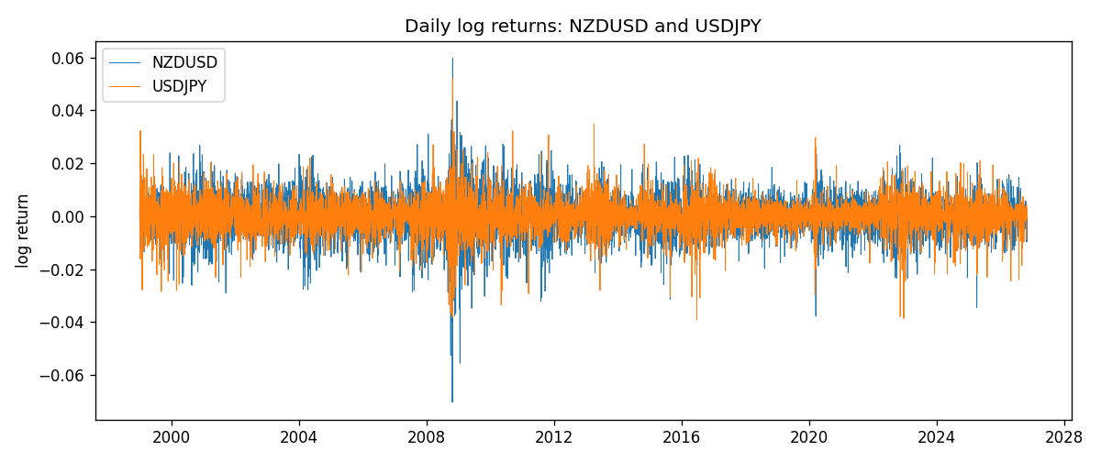
DCC rho path with Pearson r reference
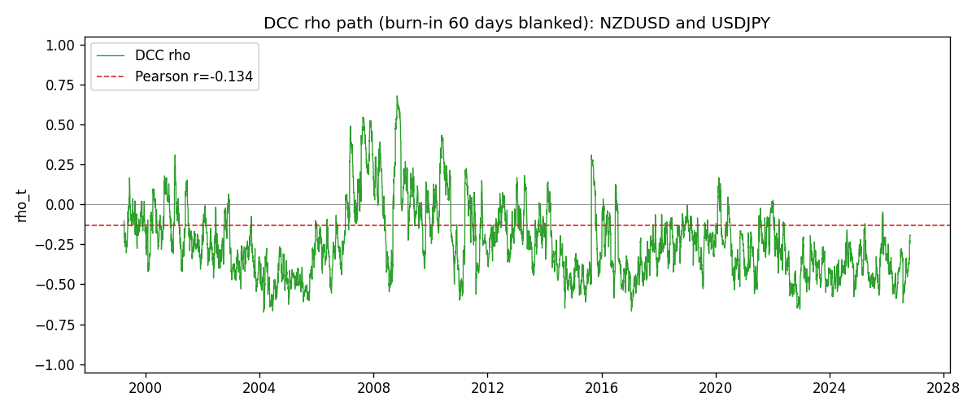

Data report
Every matched row that entered the DCC recursion is stored in the sibling Excel workbook named NZDUSD-USDJPY_DCC_D1.xlsx. Embedding all rows as a Word table is impractical at this length; the Word file holds the column list, column summaries, and the first and last 15 matched rows.
Columns: time, NZDUSD_open, USDJPY_open, NZDUSD_high, USDJPY_high, NZDUSD_low, USDJPY_low, NZDUSD_close, USDJPY_close, NZDUSD_tick_volume, USDJPY_tick_volume, NZDUSD_spread, USDJPY_spread, NZDUSD_real_volume, USDJPY_real_volume, NZDUSD_log_return, USDJPY_log_return, NZDUSD_sigma, USDJPY_sigma, NZDUSD_z, USDJPY_z, q11, q22, q12, rho_t
Column summaries (matched calculation rows)
column | count | mean | std | min | 25% | 50% | 75% | max
NZDUSD_open | 7185 | 0.65641035 | 0.10820414 | 0.3913 | 0.59133 | 0.6684 | 0.72491 | 0.88218
USDJPY_open | 7185 | 113.80829 | 19.224285 | 75.693 | 104.39 | 110.98 | 120.695 | 163.824
NZDUSD_high | 7185 | 0.6603272 | 0.1086977 | 0.3961 | 0.59474 | 0.672 | 0.72936 | 0.88421
USDJPY_high | 7185 | 114.30556 | 19.28576 | 76.001 | 104.868 | 111.439 | 121.26 | 163.978
NZDUSD_low | 7185 | 0.65272421 | 0.10779902 | 0.3897 | 0.58806 | 0.66417 | 0.72098 | 0.87988
USDJPY_low | 7185 | 113.28523 | 19.152023 | 75.402 | 103.88 | 110.53 | 120.17 | 163.628
NZDUSD_close | 7185 | 0.65648647 | 0.10820164 | 0.3907 | 0.59157 | 0.6684 | 0.72502 | 0.8822
USDJPY_close | 7185 | 113.8211 | 19.239467 | 75.811 | 104.38 | 111.015 | 120.69 | 163.851
NZDUSD_tick_volume | 7185 | 68717.699 | 123140.61 | 16 | 5585 | 33899 | 58511 | 1127682
USDJPY_tick_volume | 7185 | 106344.18 | 179438.14 | 149 | 9948 | 53202 | 92889 | 1803508
NZDUSD_spread | 7185 | 30.280167 | 25.649381 | 0 | 9 | 17 | 40 | 80
USDJPY_spread | 7185 | 20.273626 | 17.623751 | 0 | 6 | 11 | 30 | 50
NZDUSD_real_volume | 7185 | 1.6703703e+10 | 8.4983725e+10 | 0 | 0 | 0 | 0 | 2.705649e+12
USDJPY_real_volume | 7185 | 3.4781051e+10 | 1.6093614e+11 | 0 | 0 | 0 | 0 | 3.8834203e+12
NZDUSD_log_return | 7185 | 1.284e-05 | 0.0076404 | -0.07027433 | -0.00425236 | 0.00022967 | 0.00458145 | 0.05966839
USDJPY_log_return | 7185 | 4.789e-05 | 0.00620418 | -0.03908203 | -0.00320044 | 0.00011802 | 0.00340223 | 0.05184024
NZDUSD_sigma | 7185 | 0.00728456 | 0.0021657 | 0.0043892 | 0.0059587 | 0.00670471 | 0.00803321 | 0.02515282
USDJPY_sigma | 7185 | 0.00599026 | 0.00174461 | 0.00337121 | 0.00476426 | 0.00569366 | 0.00679532 | 0.01886186
NZDUSD_z | 7185 | -0.00211584 | 1.0000798 | -5.6242185 | -0.6301753 | 0.03242869 | 0.64783656 | 4.2189456
USDJPY_z | 7185 | -0.0090857 | 1.0002805 | -6.5339999 | -0.56309654 | 0.00116815 | 0.58029409 | 7.1076829
q11 | 7185 | 1.0005792 | 0.21440079 | 0.62306155 | 0.85852704 | 0.96278954 | 1.0946278 | 2.6453003
q22 | 7185 | 1.0011055 | 0.26786642 | 0.52293072 | 0.82138151 | 0.94964116 | 1.117123 | 2.8013807
q12 | 7185 | -0.2277795 | 0.25817318 | -1.1979743 | -0.38668245 | -0.25053463 | -0.10982836 | 1.5687839
rho_t | 7185 | -0.23911883 | 0.22528521 | -0.67529948 | -0.40362058 | -0.27287882 | -0.11699924 | 0.67822915
First 15 matched rows (selected columns)
time | NZDUSD_log_return | USDJPY_log_return | NZDUSD_sigma | USDJPY_sigma | NZDUSD_z | USDJPY_z | q11 | q22 | q12 | rho_t
1999-01-05 | -0.0018597736 | -0.00017868311 | 0.0058818317 | 0.011227399 | -0.31721142 | -0.025788637 | 1 | 1 | -0.22757696 | -0.22757696
1999-01-06 | 0.0020455609 | 0.0075660159 | 0.0057898202 | 0.010879378 | 0.35226489 | 0.68525608 | 0.96287894 | 0.95875325 | -0.21784627 | -0.22673097
1999-01-07 | 0.0062963171 | -0.012851583 | 0.0057033453 | 0.010680433 | 1.1029153 | -1.2136623 | 0.92891491 | 0.93929208 | -0.19906363 | -0.21310989
1999-01-08 | -0.00055396548 | -0.0047719894 | 0.0057453083 | 0.010767788 | -0.097466665 | -0.45346784 | 0.94203831 | 0.96239277 | -0.24659981 | -0.25898957
1999-01-11 | 0.010290425 | -0.016195423 | 0.0056466865 | 0.010495359 | 1.8213185 | -1.5536657 | 0.90457328 | 0.93182301 | -0.23426104 | -0.25515935
1999-01-12 | -0.0053157489 | 0.032310364 | 0.0059213374 | 0.010835232 | -0.89874282 | 2.9717416 | 1.0058397 | 0.99419895 | -0.34126836 | -0.34126755
1999-01-13 | -0.0099742238 | 0.0081373171 | 0.0059131577 | 0.012826479 | -1.6878011 | 0.62577273 | 0.99755998 | 1.3177694 | -0.43540917 | -0.37975924
1999-01-14 | -0.00018564931 | 0 | 0.0061435477 | 0.012557425 | -0.031196936 | -0.0088279399 | 1.0740063 | 1.2739241 | -0.45735655 | -0.39100266
1999-01-15 | -0.00074294208 | 0.0055343401 | 0.0060312548 | 0.012162783 | -0.12417858 | 0.44590815 | 1.0284093 | 1.2165042 | -0.4344057 | -0.38837898
1999-01-18 | -0.0018597736 | 8.7600193e-05 | 0.005924283 | 0.011846977 | -0.3149384 | -0.0019630327 | 0.98609673 | 1.1706729 | -0.41510471 | -0.38634929
1999-01-19 | 0.0018597736 | -0.0056219403 | 0.0058308311 | 0.01147705 | 0.31792433 | -0.49950085 | 0.94973602 | 1.119337 | -0.39463063 | -0.38274445
1999-01-20 | 0.0040793678 | -0.0053879917 | 0.0057404005 | 0.011197123 | 0.7095946 | -0.49109473 | 0.91559691 | 1.0813254 | -0.38194358 | -0.38385646
1999-01-21 | 0.0040627941 | 0.0084664056 | 0.0056997214 | 0.010922633 | 0.7117512 | 0.76497579 | 0.90008118 | 1.045211 | -0.37783315 | -0.38954464
1999-01-22 | -0.012051689 | 0.0060412564 | 0.0056602896 | 0.010756311 | -2.1302267 | 0.55134146 | 0.88560668 | 1.0254246 | -0.33710923 | -0.35375154
1999-01-25 | -0.0035504102 | -0.0073594164 | 0.0060665885 | 0.010512579 | -0.58623075 | -0.71060326 | 1.0383732 | 0.99519794 | -0.36973462 | -0.36371286
Last 15 matched rows (selected columns)
time | NZDUSD_log_return | USDJPY_log_return | NZDUSD_sigma | USDJPY_sigma | NZDUSD_z | USDJPY_z | q11 | q22 | q12 | rho_t
2026-10-13 | 0.0047326165 | -0.0018932826 | 0.0049272906 | 0.0048667878 | 0.95927078 | -0.41179908 | 0.7223714 | 0.77951633 | -0.27683153 | -0.36891191
2026-10-14 | -0.0037306483 | 7.5800166e-05 | 0.0049467361 | 0.0047810428 | -0.75537864 | -0.0073322979 | 0.73544505 | 0.75823974 | -0.28083914 | -0.37607914
2026-10-15 | 0.0047634855 | -0.0018524319 | 0.004931073 | 0.0046770543 | 0.96479506 | -0.41977022 | 0.73331835 | 0.73122049 | -0.26807746 | -0.36609167
2026-10-16 | 0.0057501001 | -0.00037976126 | 0.004951509 | 0.0045996653 | 1.1600685 | -0.10666373 | 0.74618534 | 0.71306473 | -0.27301247 | -0.3742783
2026-10-19 | 0.0018917133 | 0.0034946841 | 0.0050126444 | 0.0045051772 | 0.37618921 | 0.75109762 | 0.77541965 | 0.68917609 | -0.26604796 | -0.36393718
2026-10-20 | 0.0037199341 | -0.0022546642 | 0.0049518372 | 0.0044809423 | 0.75000922 | -0.52790691 | 0.75322641 | 0.68951094 | -0.24272466 | -0.33680657
2026-10-21 | 0.0030923331 | -0.00032883504 | 0.0049352483 | 0.004423674 | 0.62536318 | -0.099395036 | 0.74971781 | 0.67804384 | -0.24878049 | -0.34893016
2026-10-22 | -0.0033035227 | -0.0085942669 | 0.0049019278 | 0.004336985 | -0.67514932 | -2.0071831 | 0.73934022 | 0.65615801 | -0.24070292 | -0.34558507
2026-10-23 | 0.0030929853 | 0.00035080446 | 0.0048759294 | 0.0046962172 | 0.63310489 | 0.051093946 | 0.73224683 | 0.8014395 | -0.17460338 | -0.22792319
2026-10-26 | -0.0028993932 | 0.0041238746 | 0.0048451676 | 0.0045963222 | -0.59964978 | 0.87309338 | 0.72330135 | 0.77197898 | -0.16699819 | -0.22348552
2026-10-27 | -0.00026399852 | 0.0027651658 | 0.0048111842 | 0.0045932503 | -0.056121127 | 0.57787174 | 0.71318101 | 0.77561053 | -0.18278561 | -0.24576514
2026-10-28 | -0.0097283914 | -0.00095679538 | 0.0047432635 | 0.0045384516 | -2.0522583 | -0.23524578 | 0.68894593 | 0.76134791 | -0.17737174 | -0.24490648
2026-10-29 | 0.00062190714 | -0.00038043789 | 0.0050688642 | 0.0044520434 | 0.12150584 | -0.11035249 | 0.8398468 | 0.73642735 | -0.15101192 | -0.19201989
2026-10-30 | 0.00019537668 | -0.0010596481 | 0.004993171 | 0.004364329 | 0.037925023 | -0.268198 | 0.80862363 | 0.71119443 | -0.1466861 | -0.19342899
2026-11-02 | -0.0025962955 | 0.0026438521 | 0.0049187094 | 0.0042875892 | -0.52906278 | 0.59077391 | 0.7786912 | 0.68991533 | -0.1424817 | -0.19439207

